How it looks like…

FTK Imager’s user interface looks very simple. UI is divided into several panes. Each pane can be changed individually or we can reset the entire view for the next investigation.

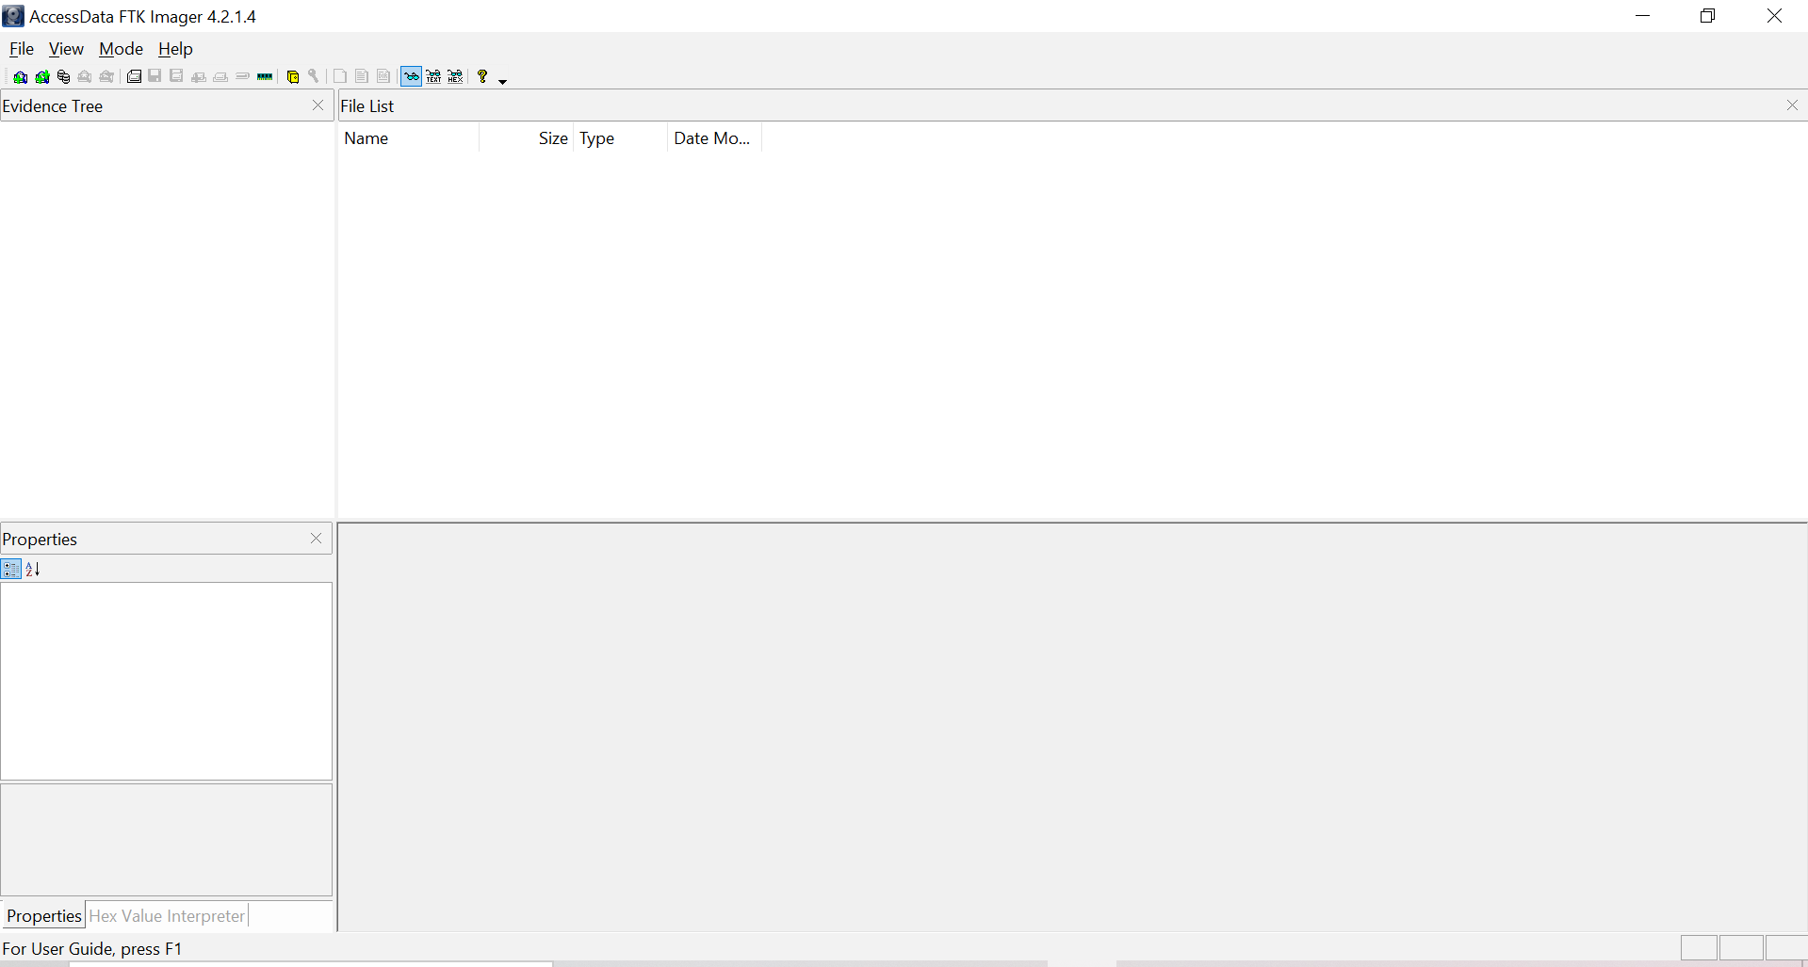

Status Bar

Properties/ Hex value Interpreter

Evidence Tree

Viewer

File List

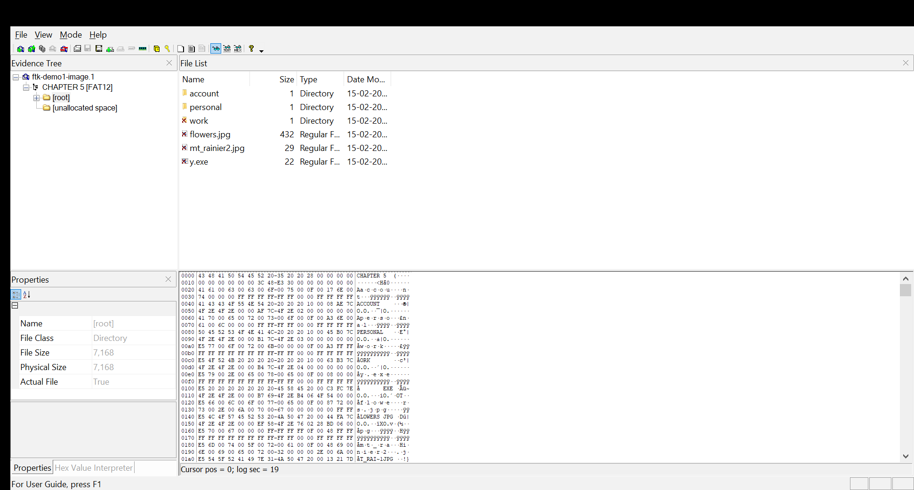

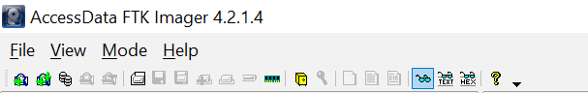

Toolbar

Menu bar

We can use Menu Bar to perform various task on digital media that can help the investigator to acquire evidence from it.

